***3.***Develop a system using UML for implementing the Exam Registration Portal. It should verify the details of the candidate by the central computer. The details regarding the candidate will be provided to the central computer through the administrator and the computer will verify the details of the candidate and provide approval. Then the hall ticket will be issued from the office to the candidate.

***USE CASE DIAGRAM:***

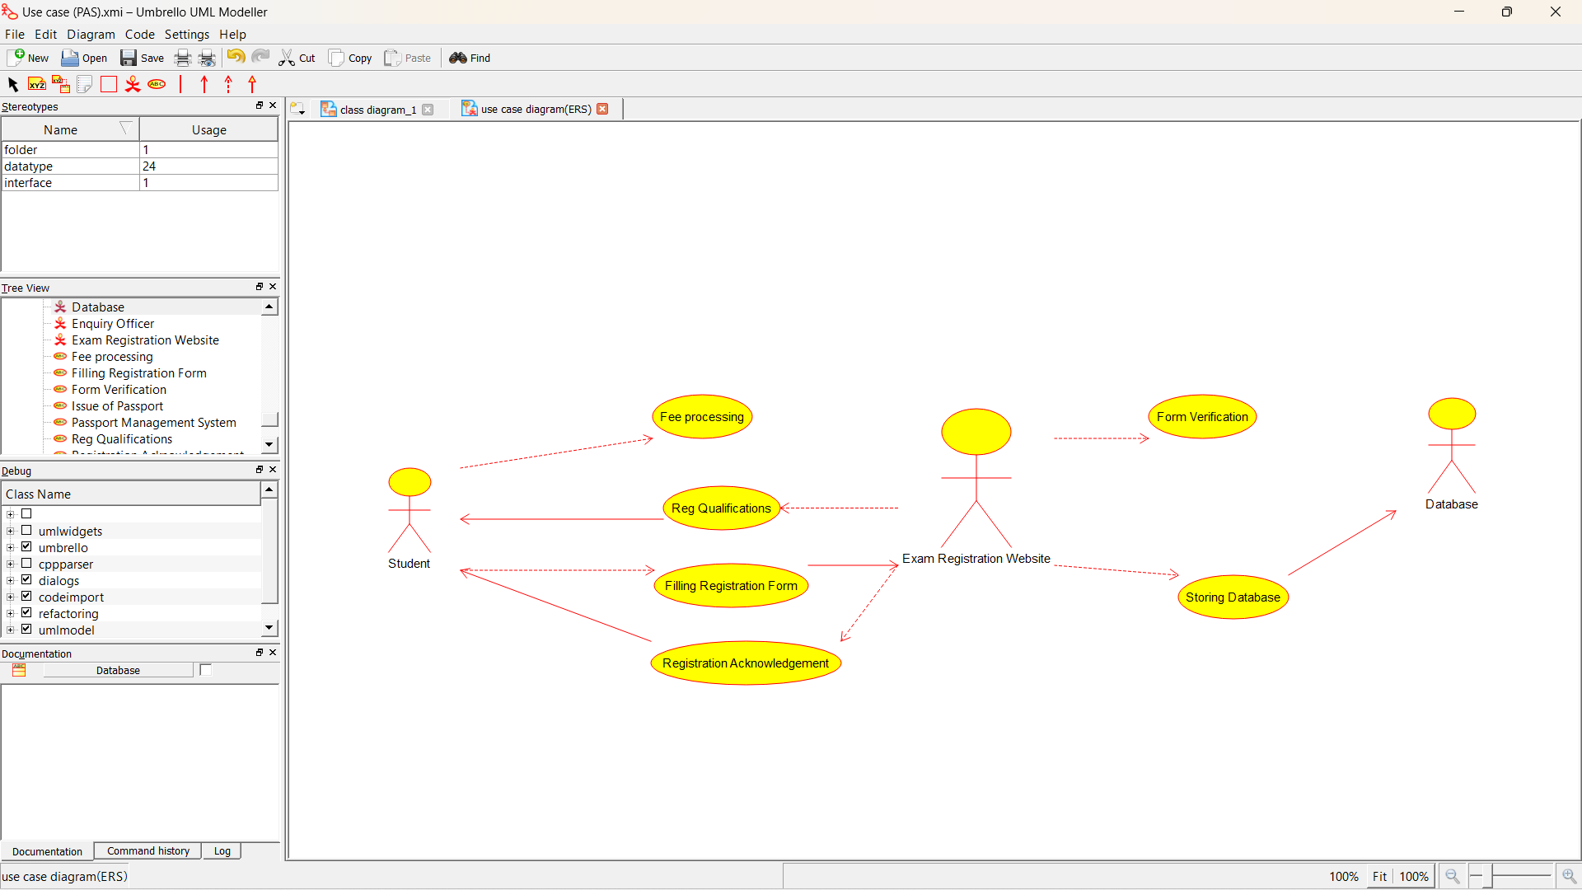

***CLASS DIAGRAM:*** 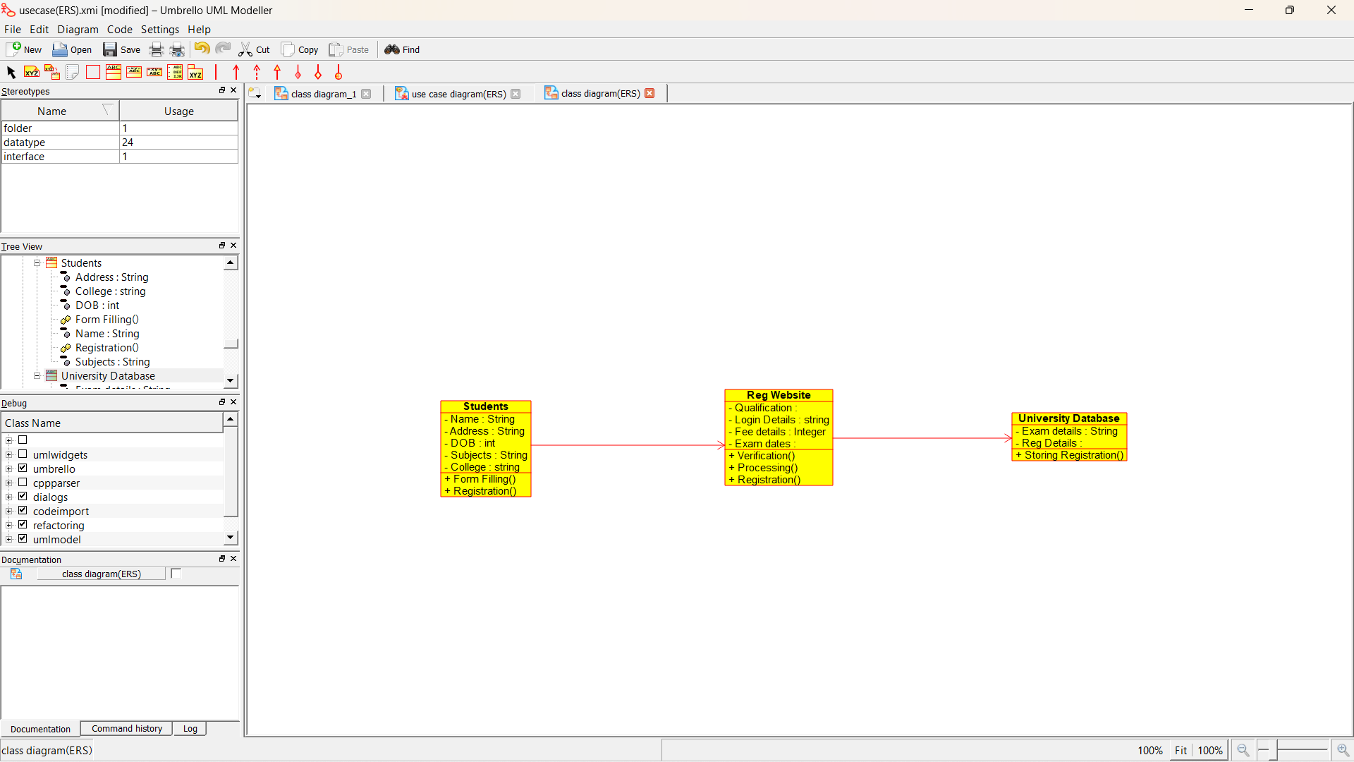

***ACTIVITY DIAGRAM:***

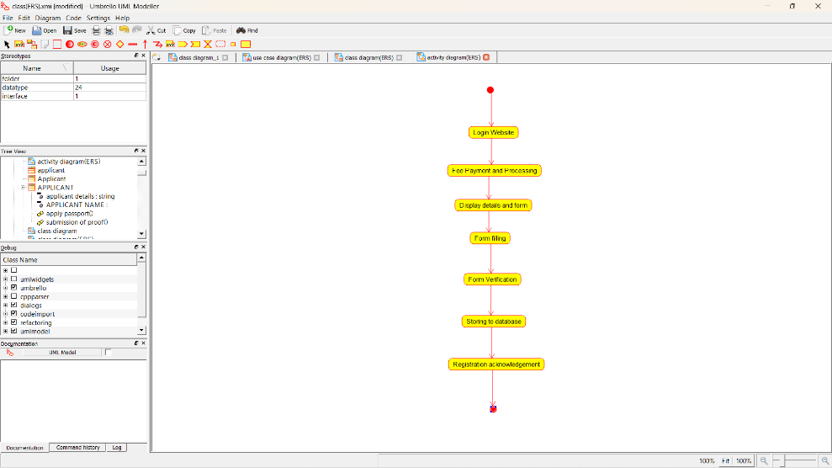

***SEQUENCE DIAGRAM:***

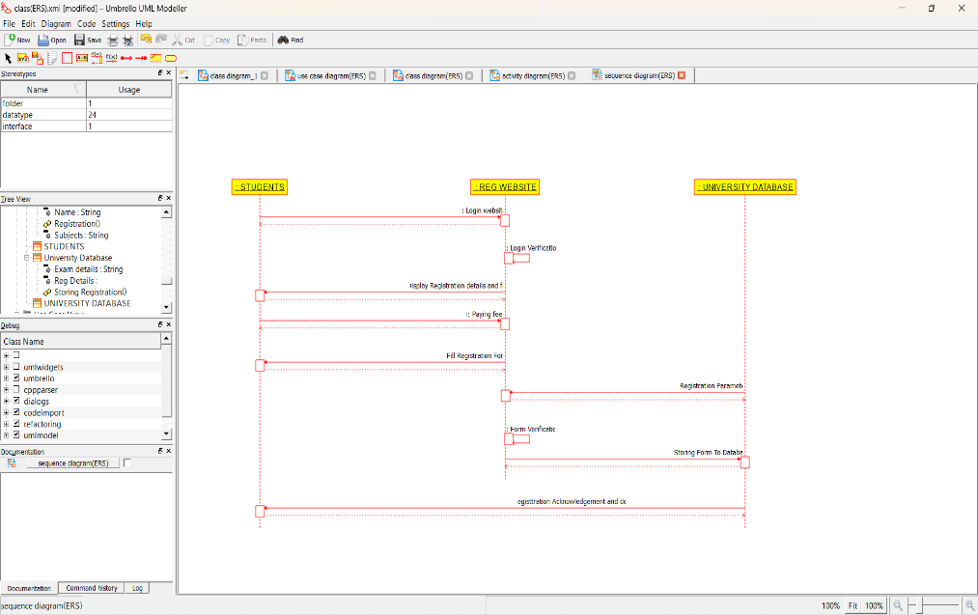

***COLLABORATION DIAGRAM:***

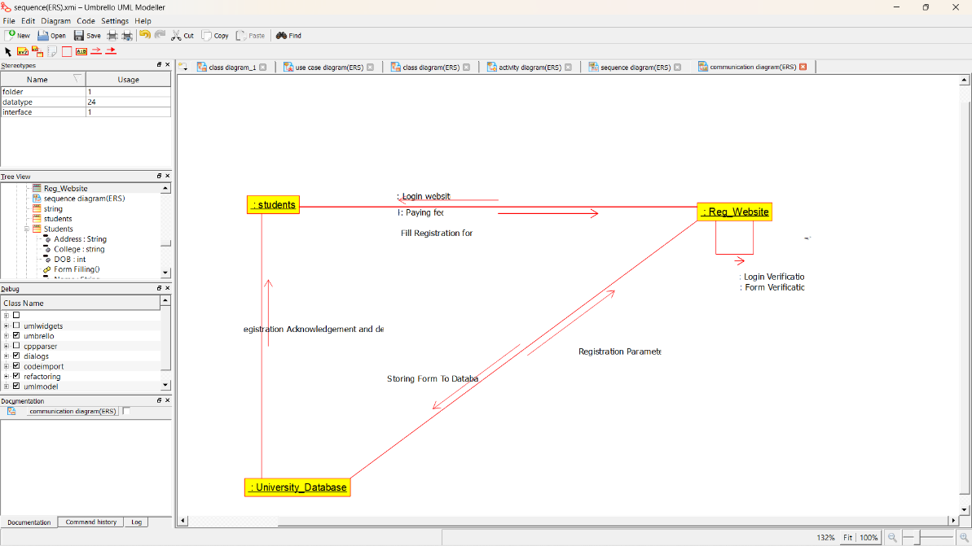

***STATE DIAGRAM:***

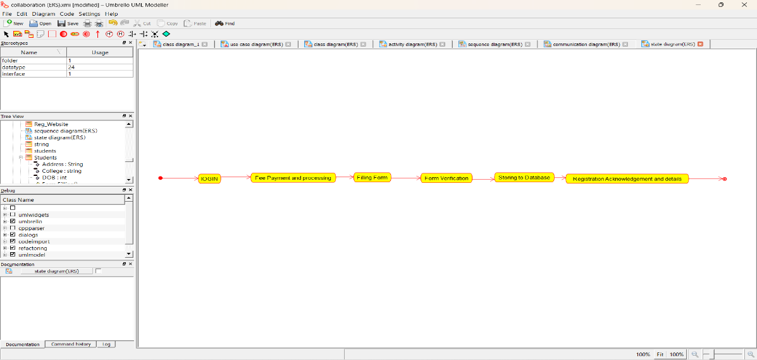

***COMPONENT DIAGRAM:***

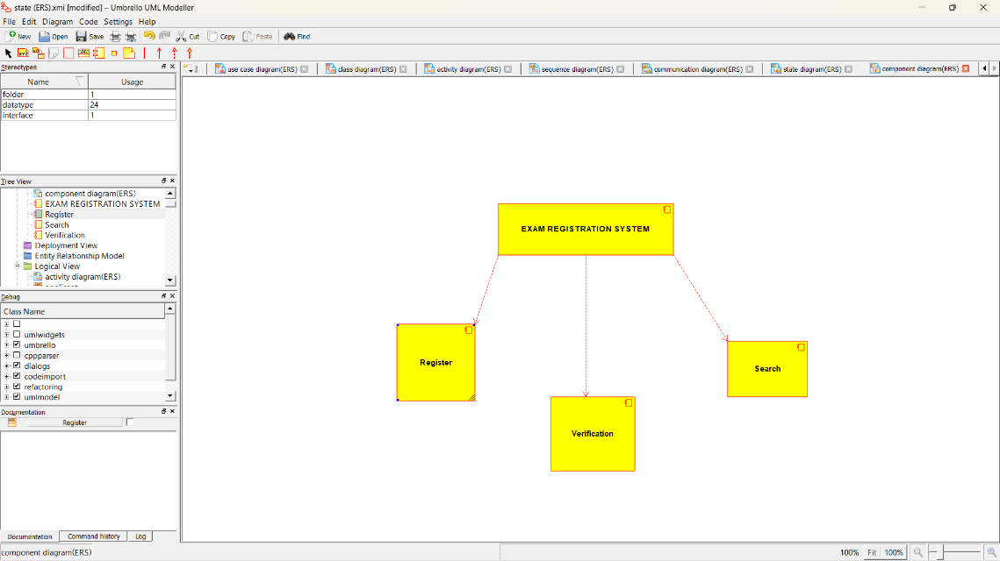

***DEPLOYMENT DIAGRAM:*** 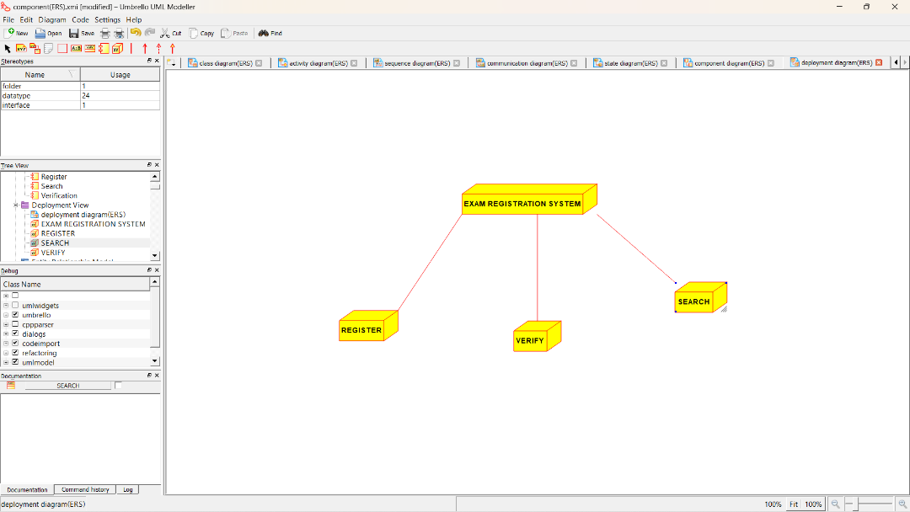

***192211012***

***GB Reenasri***